<https://www.vmware.com/products/player>

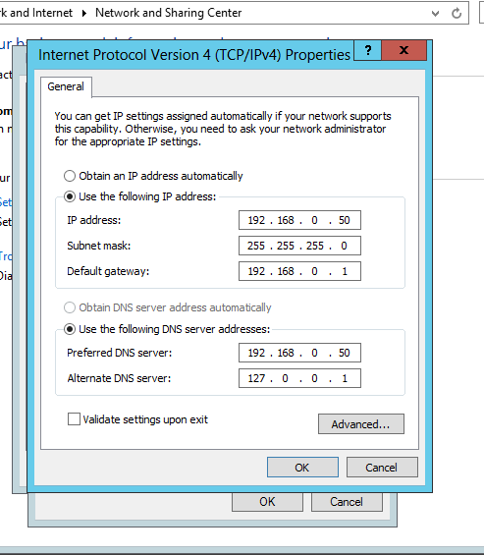

Dc ip address

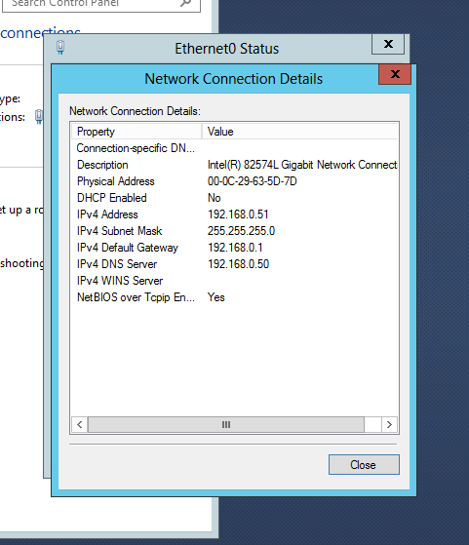

Workstarion ip address